00:12
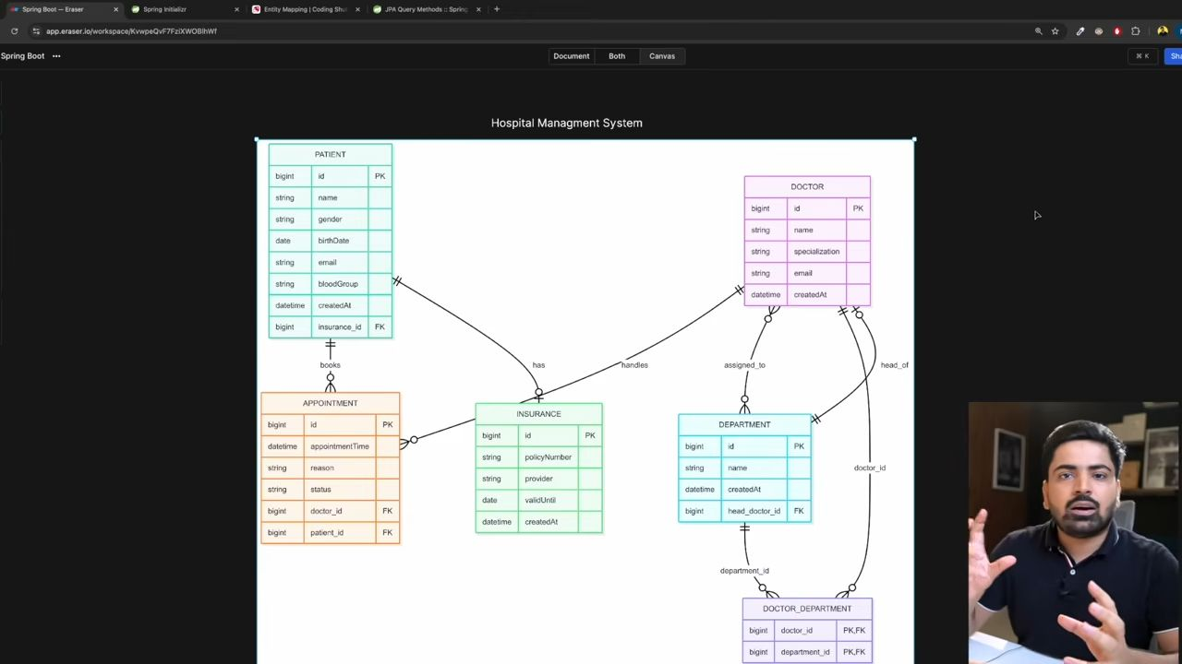
The patient has partial participation, and insurance has full means. Insurance bina patient k exist ni kr skta, but the patient bina insurance k exist kr skta hai.
14:03
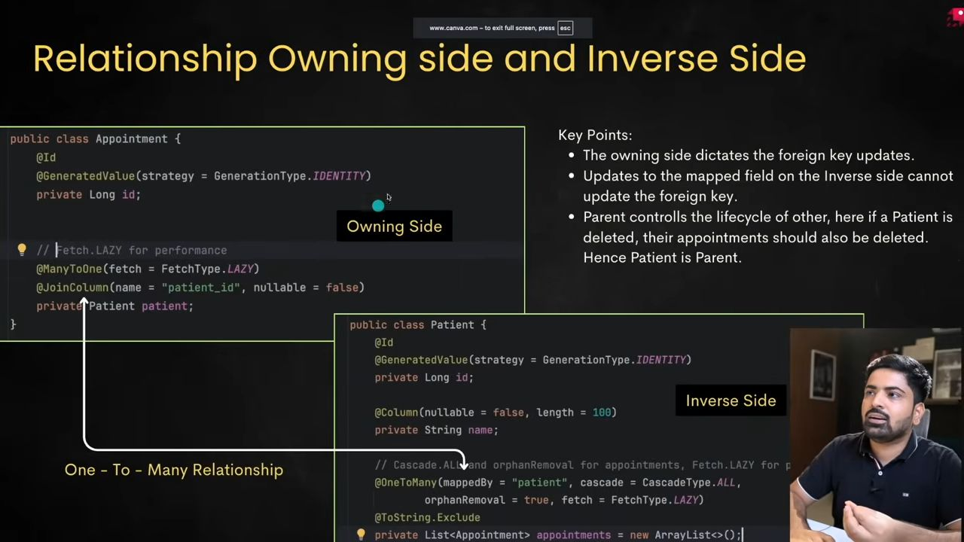
Patient----> Appointment (OneToMany)
Appointment----> Patient (ManyToOne)
Here, Appointment is the owning side.
25:07
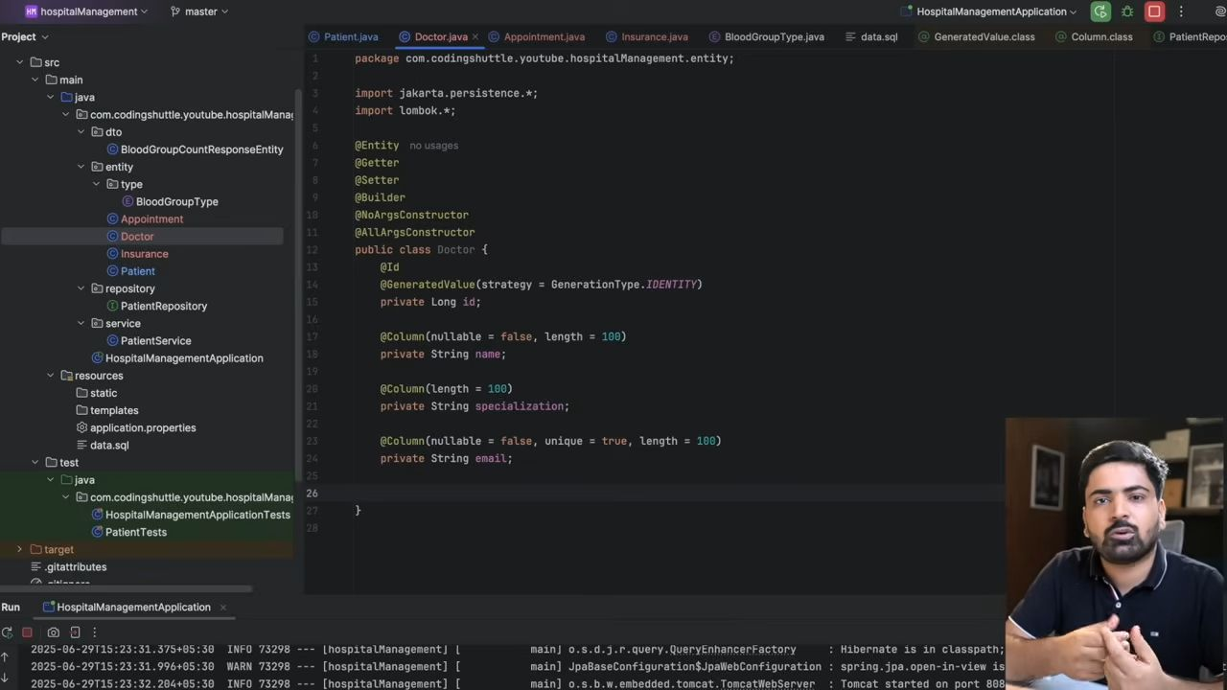Here Doctor bina appointemnt k rhe skta hai but appointment ko exist krne k liye doctor chahye.
So, idhar pe owning side hai appointment. Appointment ---> Doctor (ManyToOne)
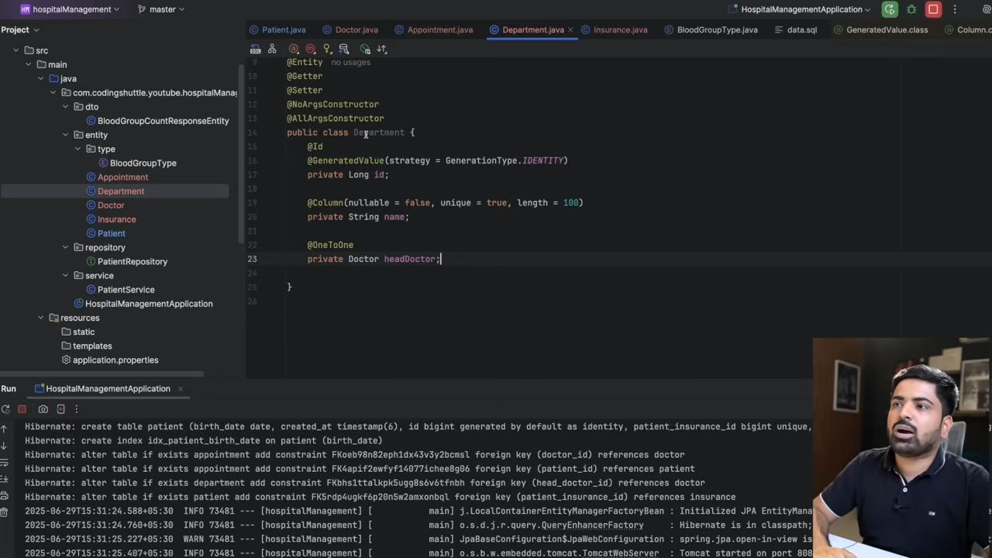
ManyToMany mapping mai JoinTable bnti hai, na ki join column.
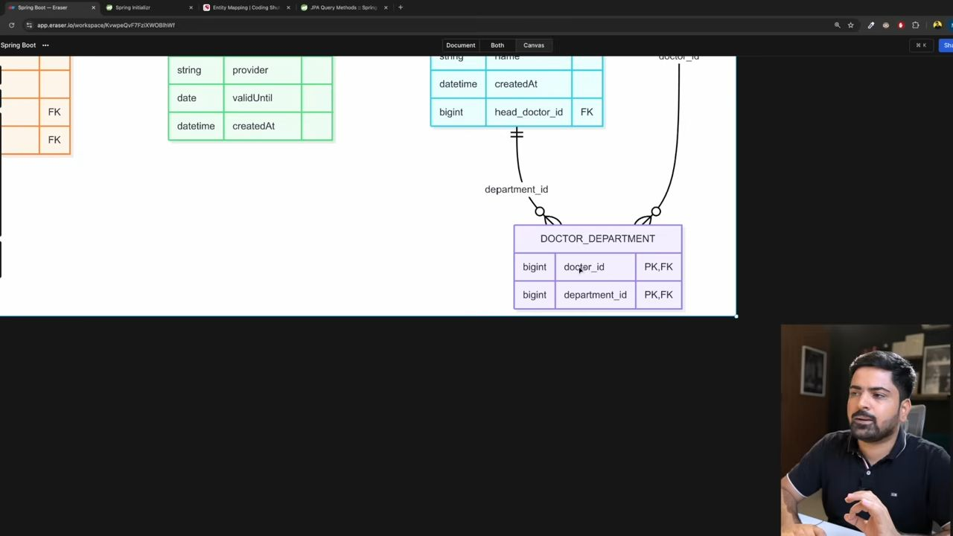
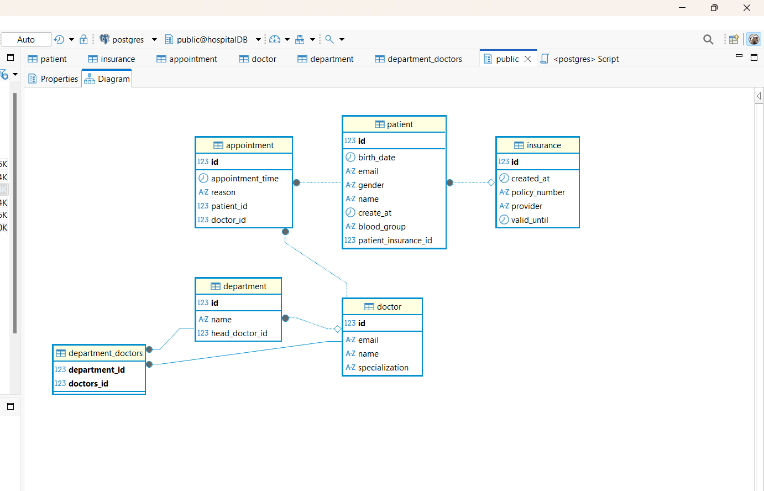
Install the plugin JPA Buddy
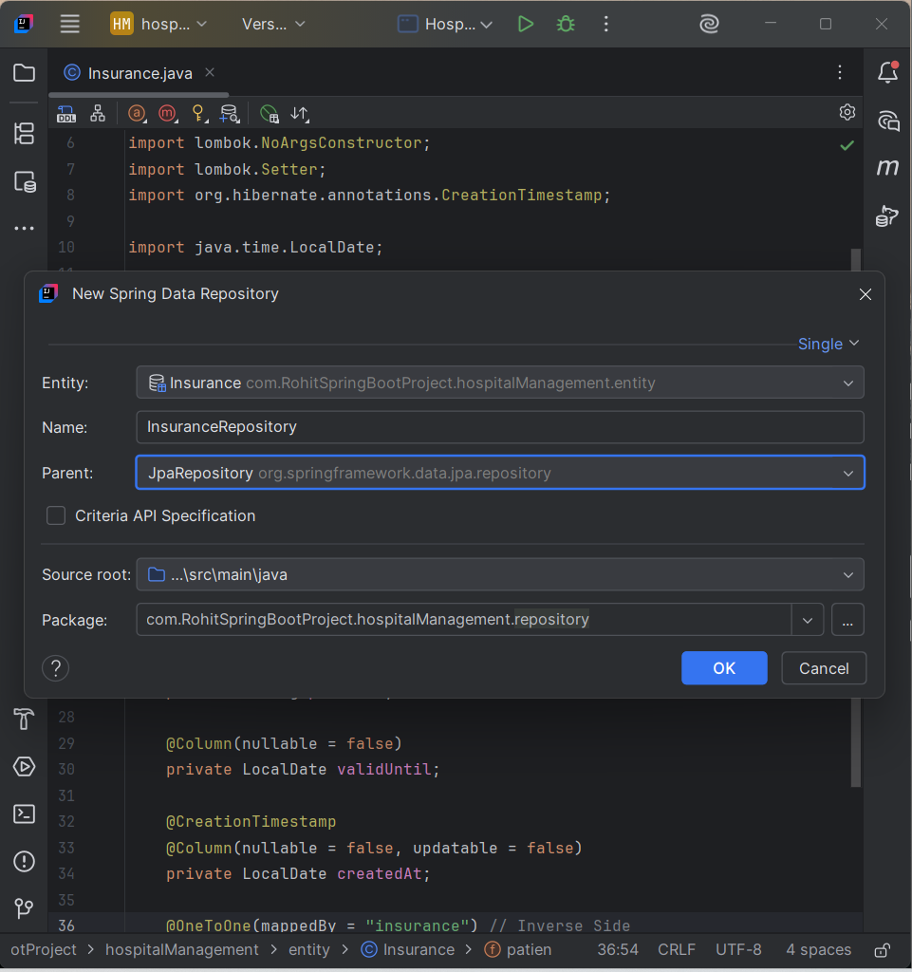This green option make repository for you.
55:54
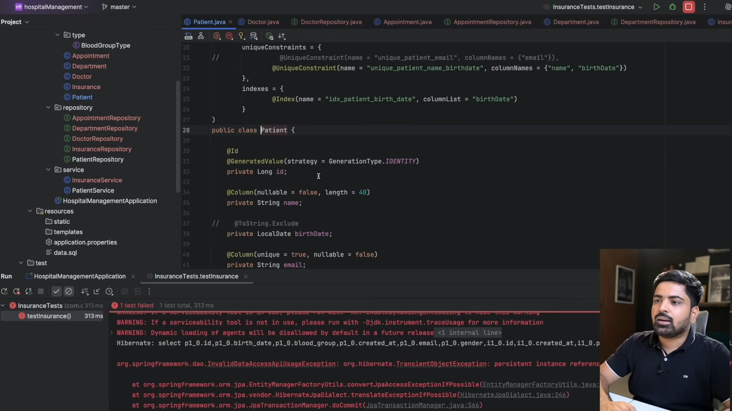
Ye error isliye aya because humne proper cascading define he nhi ki hai ki jab parent entity k sath kuch bhi operation perform ho toh child entity k sath kya hona chahye.
56:12
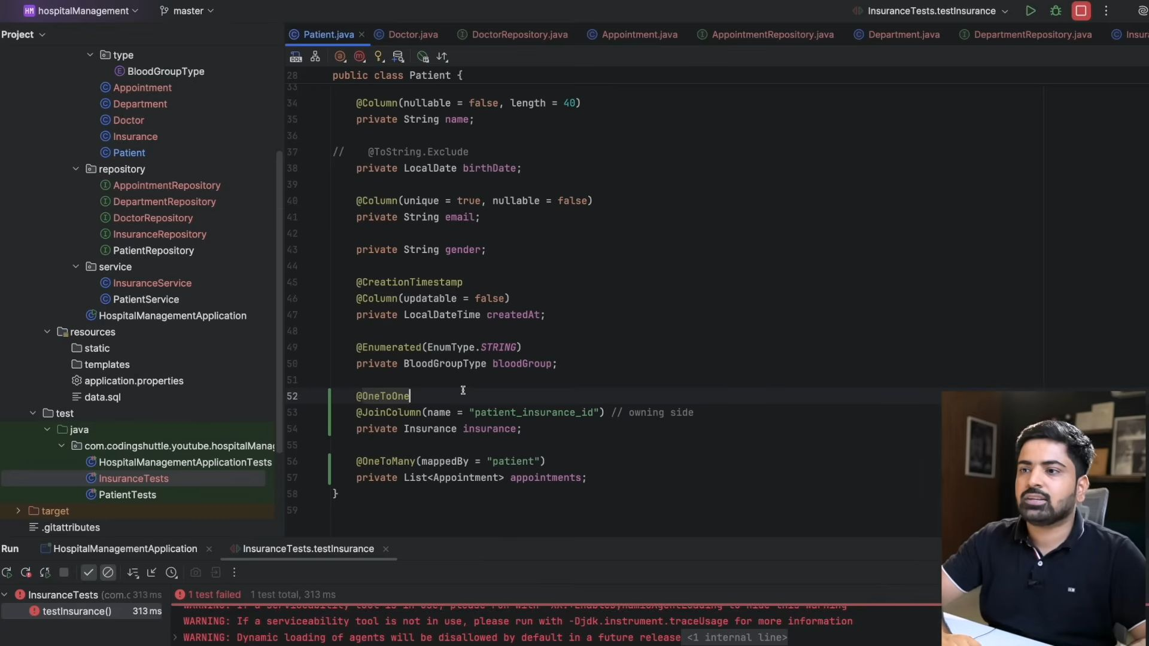
Yaha pe insurance banaya hai maine patient entity mai and now i want ki jab bhi mai ko update operation perform kru parent (patient) entity mai toh child entity (insurance) mai bhi wo same operation perform ho jaye and uske liye he hum use krte hai cascading.
58:00
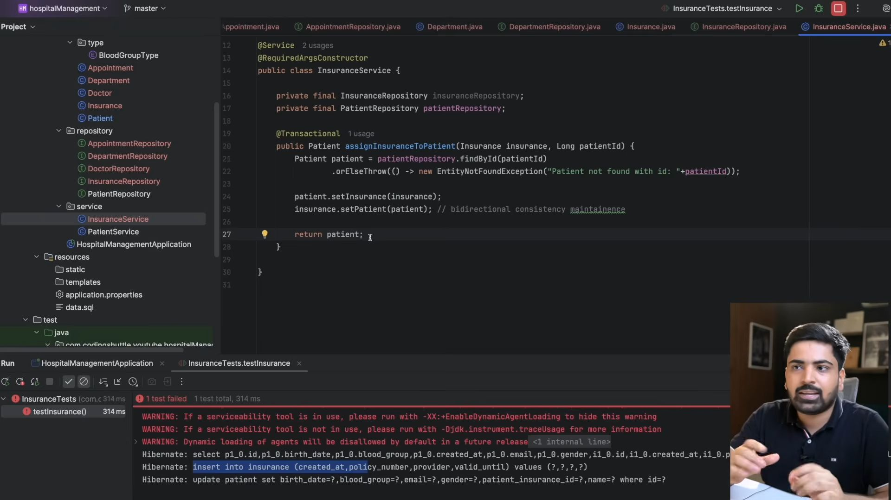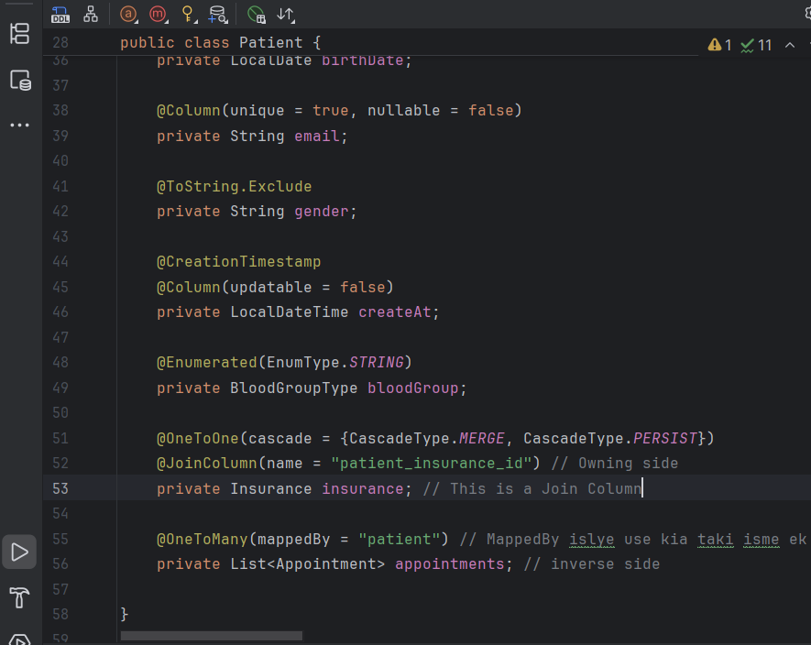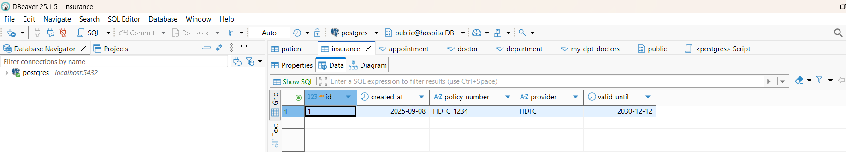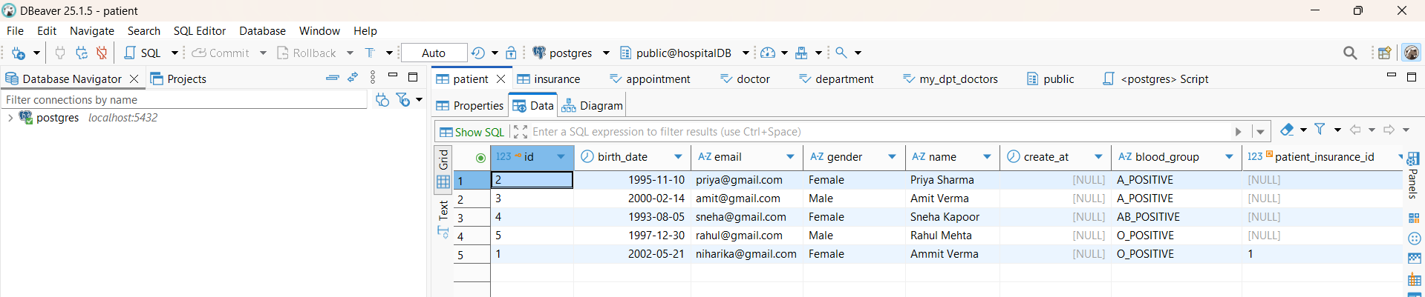
Patient save islye hora hai kyuki hum transactional context k ander hai, and yaha pe dirty ho gya h toh jab ye method khtm hoga transactional check krega ki yaha pe dirty hua h kuch ki ni and idhr hua h toh wo update ke dega patient k changes ko database mai, and fir wo dekhega ki insurance ko update krna hai but insurance toh hai he nhi idhr toh kyuki cascading type humne MERGE define ki hai toh phele insurance ko save kia jayega. And uske baad uss insurance se jo id milegi usse iss patient ko save kr lia jayega, and uske baad patient ko update kr lia jayega.
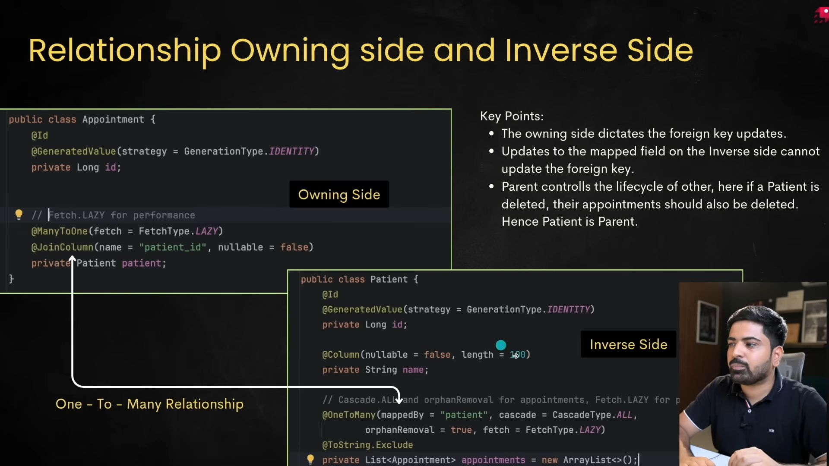
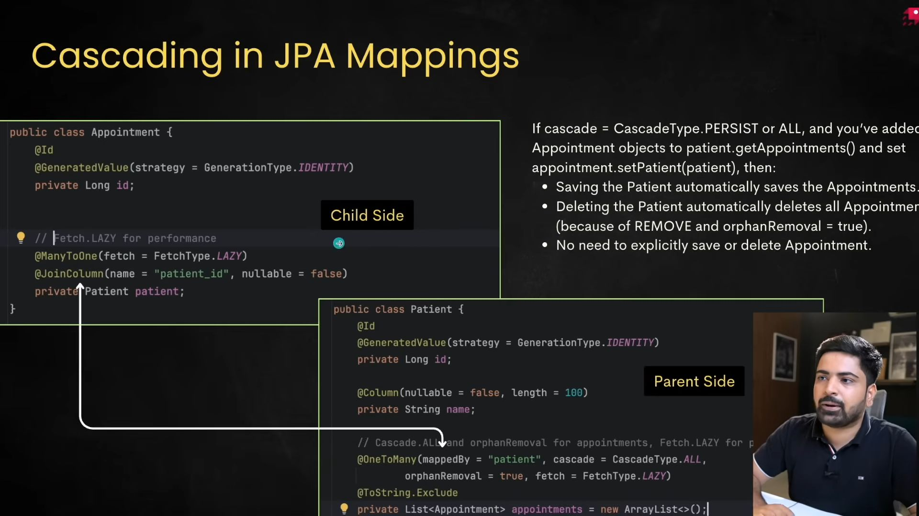
01:01:55
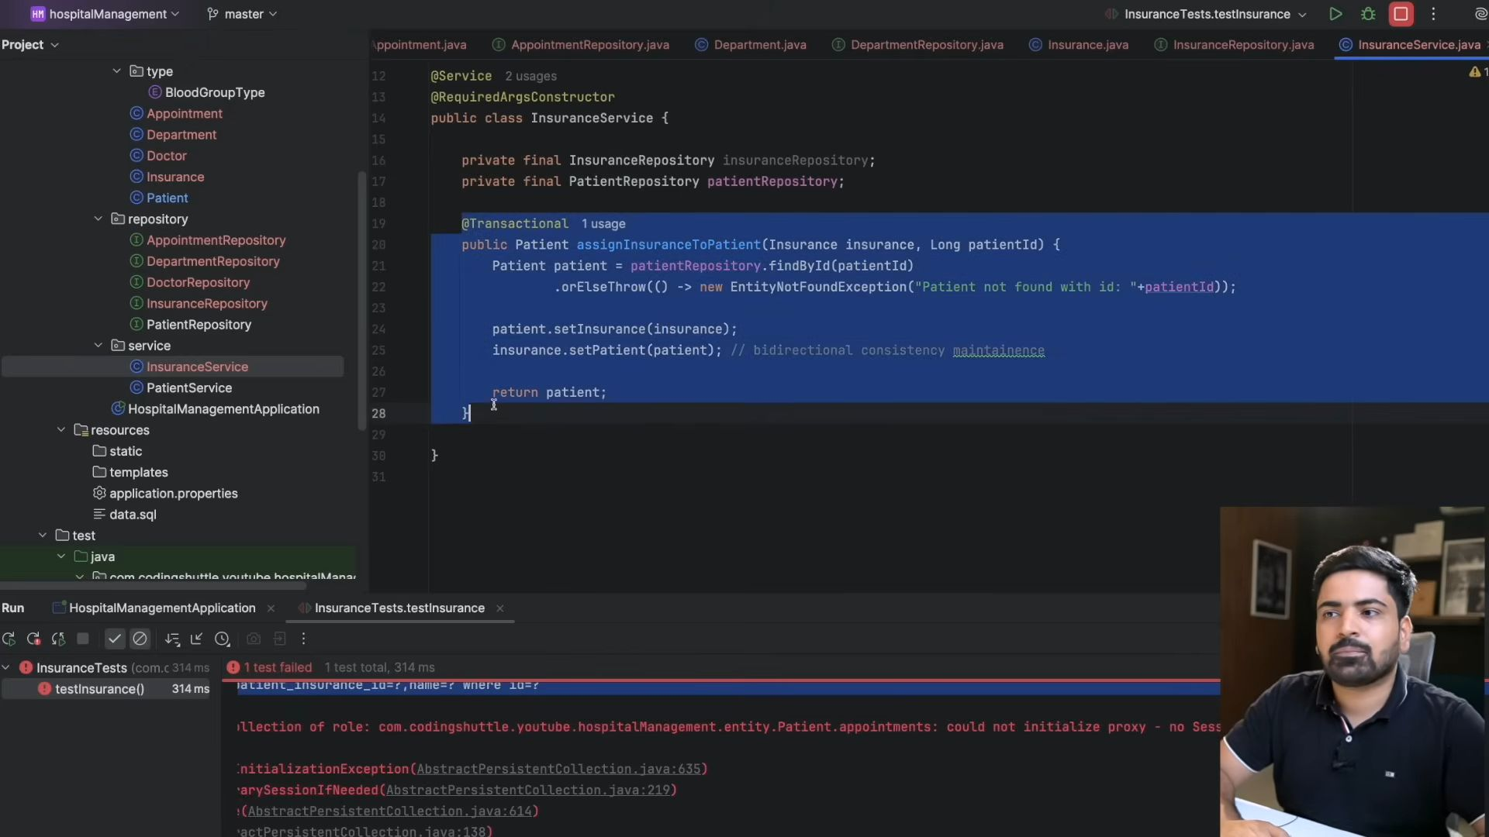
Yaha pe jab ye transactional wala method khtm hua toh session over ho gya.
01:02:03
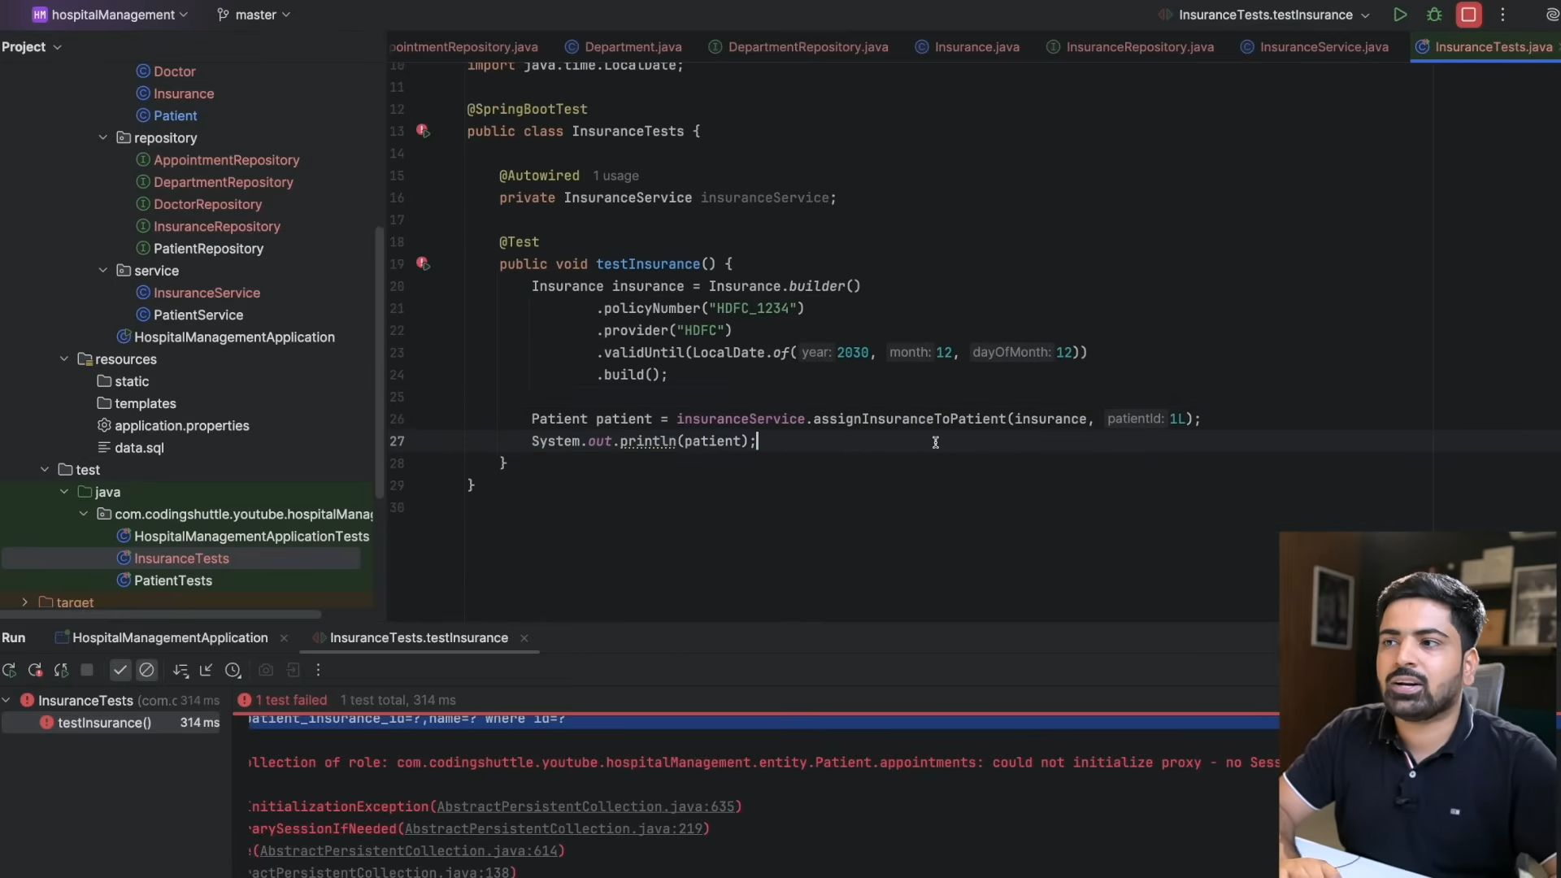
Kyuki session over ho gya hai and aap yaha pe usko print krane ki kosis krre ho, and patient ko hum print toh kr denge, but patient k ander ek lazy cheez fetch hori h jo ki h appointment.
01:02:11
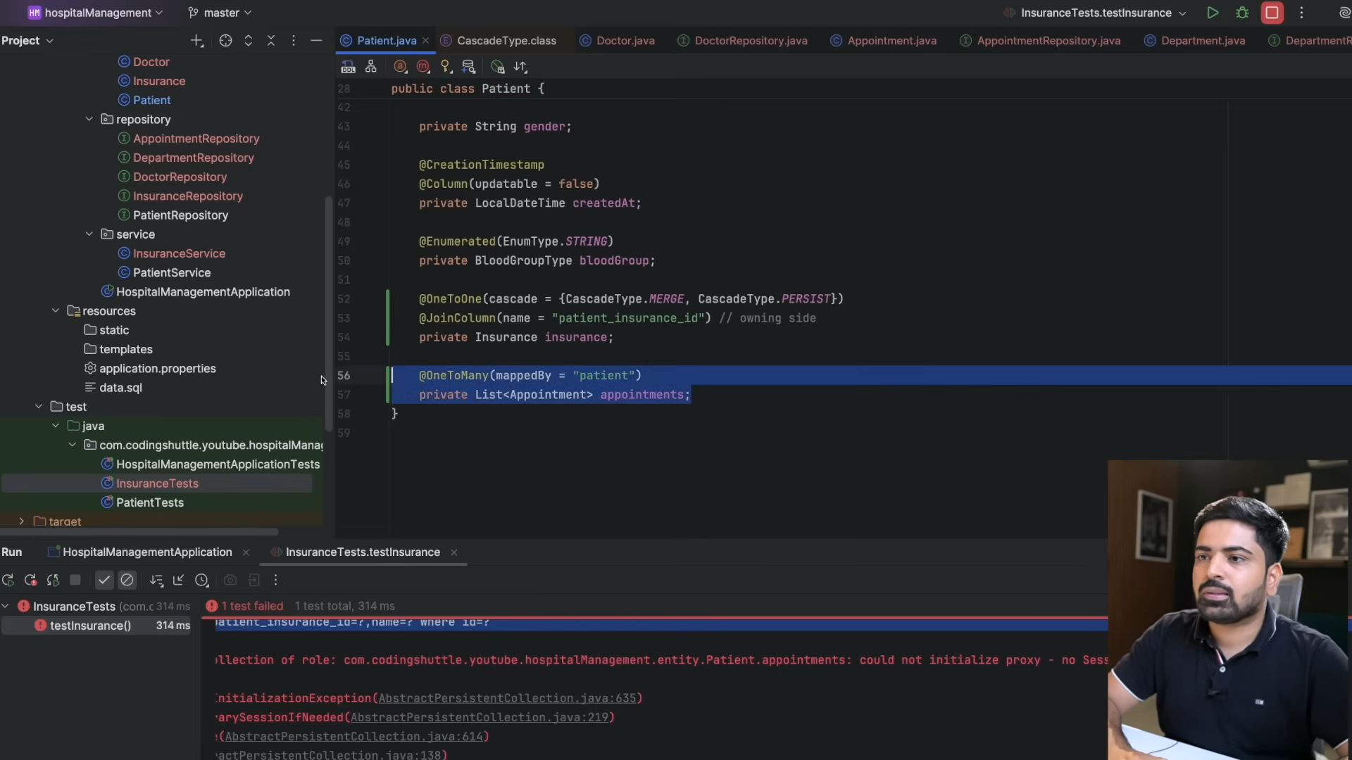
Ilsye isko hum fetch ni kr skte and hume ye error aari h.
01:03:21
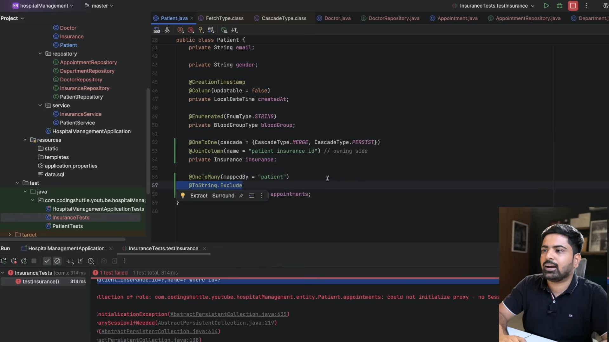
Ya toh ye exclude kr do ya fir fetch type eager kr do. and fir ye error ni ayegi.
01:32:01
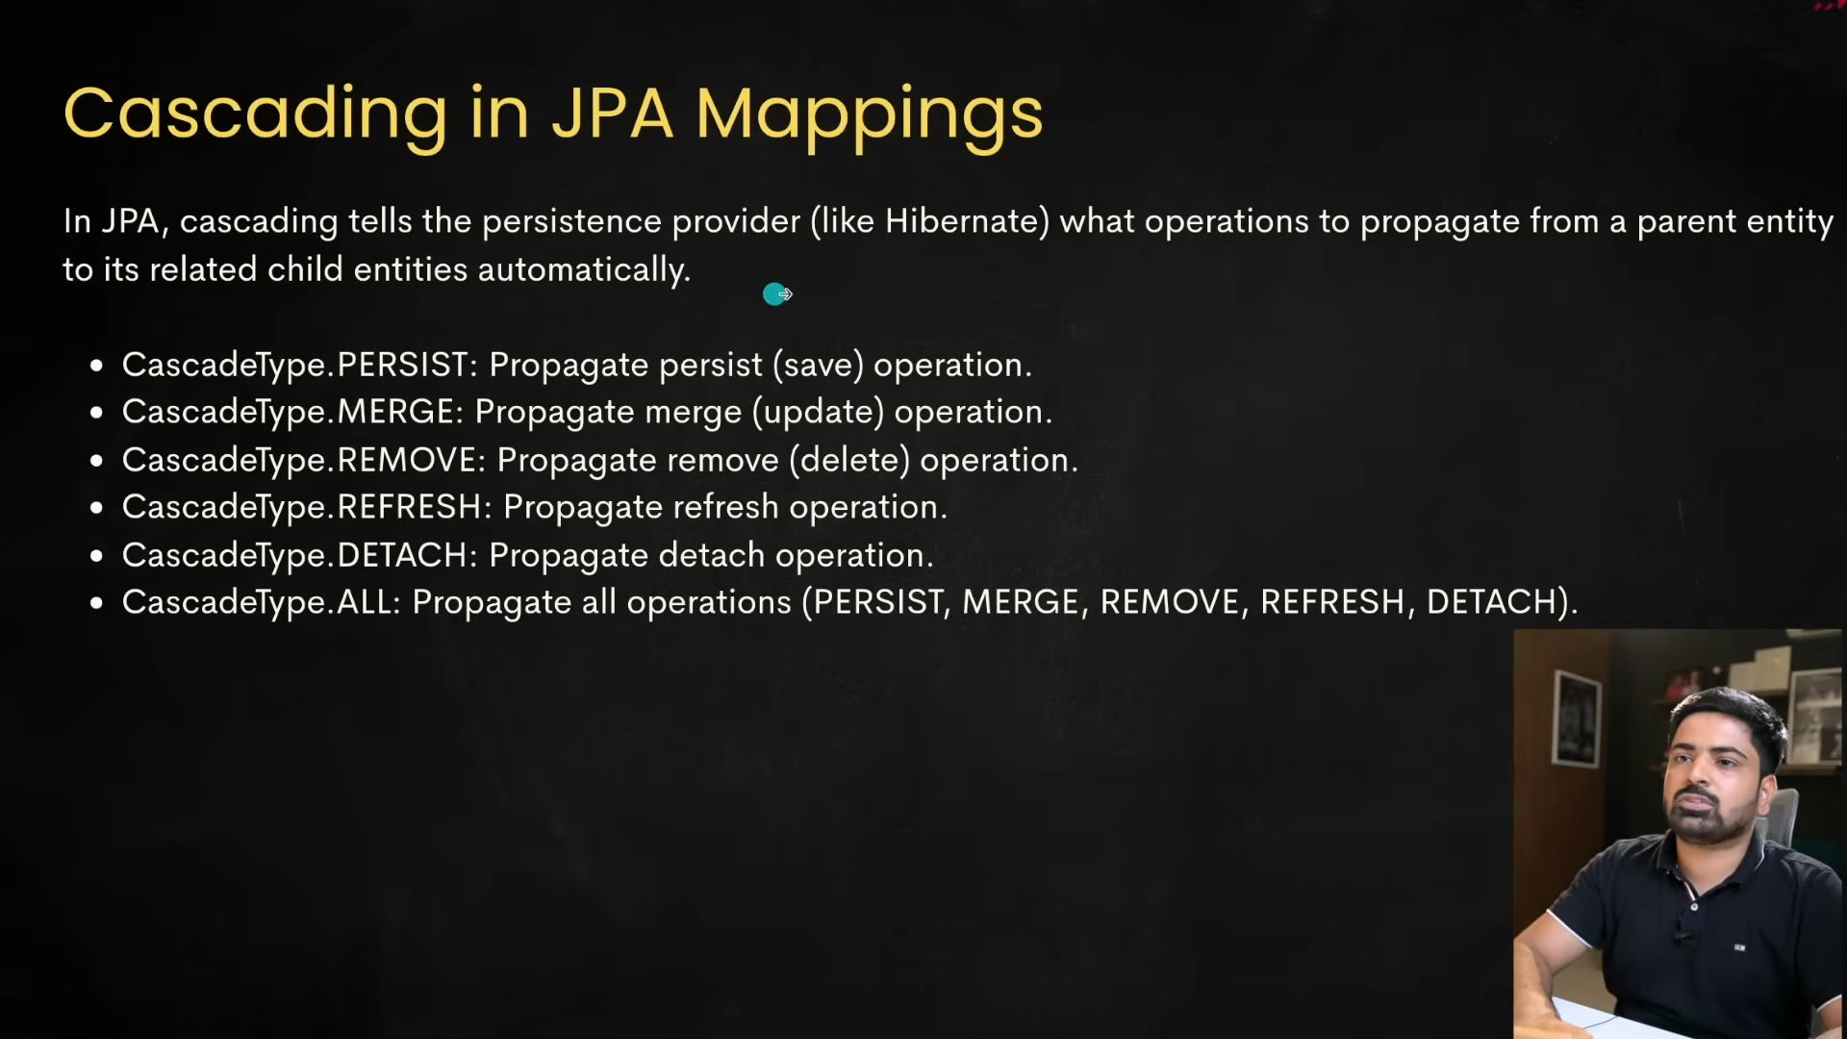
01:32:42
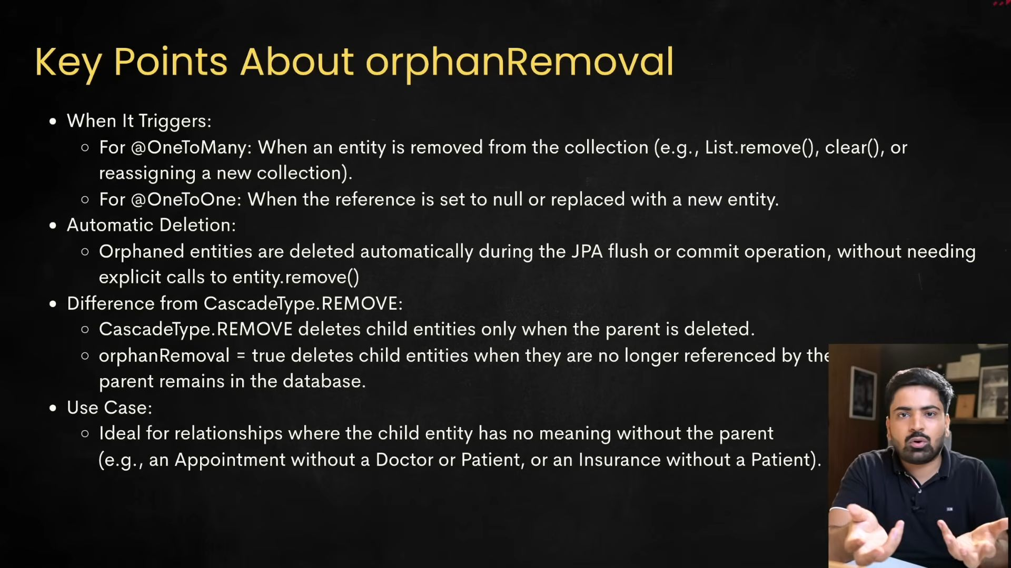
Jab aap chahate ho child ko delete krna without deleting the patient, then you need orphan removal.
And if you want ki child delete ho jaye as soon as I delete the patient, then you need CASCADE. TYPE = REMOVE

